April 22, 2023
Ref: IIH/MD/2023/04/020

The Branch Manager,
Premium Trust Bank,
Umaru Audi Road, Tanke Junction,
GRA, Ilorin, Kwara State

Dear Sir,

APPLICATION TO OPEN CORPORATE CURRENT ACCOUNT WITH YOUR BANK
We the directors of Ilorin Innovation Hub Ltd (RC1664691) write to apply for a Corporate Current Account with your bank.

We also request that necessary mandate be given to the Managing Director of Ilorin Innovation Hub Ltd, Mr. Temiloluwa Kolawole, to manage the account and assign mandate to other employees or project partners of the company.

Attached is his letter of appointment and any other necessary documents to support this application.

Yours sincerely,

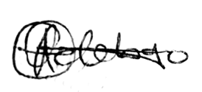


__________________ ___________________
Abdulmajeed Abdullahi Oluwasegun Adebayo

